- A mesh network is a local area network topology in which the nodes (i.e. bridges, switches, and other infrastructure devices) connect to as many other nodes as possible and cooperate with one another to efficiently route data to and from clients
- Example of fully connected mesh:
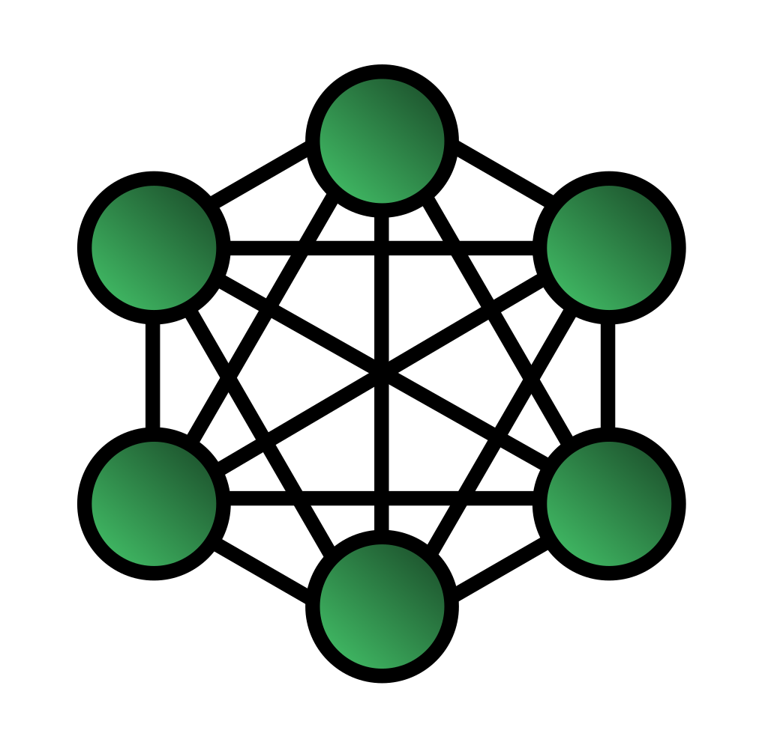
- Creating a mesh network can help with sending information from the PCB to remote devices and other outside sources.
- This will require the protocols researched (i.e. Zigbee, Bluetooth, etc.)
- Power consumption will need to be a consideration, especially with the use of a coin-cell battery
- Possibly need to provide security due to the use of the USB-connected port to program
- There will be some latency issues that will need to be addressed
- Mesh networks can relay messages using either a flooding or a routing technique
  - Flooding = when a node receives a message from a messenger node, it will send to all other nodes that it is linked to, except the messenger
  - Routing = the process of selecting a path of nodes to send the message
- These are self-healing
- Self-healing allows a routing-based network to operate when a node breaks down or when a connection becomes unreliable
- Fully connected wired networks are more secure and reliable, since problems in a cable affect only the two nodes attached to it
- The number of cables will bring the cost up rapidly as the number of nodes increases
- This also makes it less portable
- Two techniques of self-healing:
- Shortest Path Bridging
- TRILL (Transparent Interconnection of Lots of Links)
  - a networking protocol for optimizing bandwidth and resilience in Ethernet networks
  - Implemented through TRILL switches
- A wireless mesh network (WMN) is a network made up of radio nodes organized in a mesh topology
- Data hops from one device to another until it eventually reaches its destination
- Dynamic routing algorithms implemented in each device allow this to happen
- To implement such dynamic routing protocols, each device needs to communicate routing information to other devices in the network. Each device then determines what to do with the data it receives – either pass it on to the next device or keep it, depending on the protocol.
- The routing algorithm used should attempt to always ensure that the data takes the most appropriate (fastest) route to its destination\
- An application of this WMN is smart home devices such as Google Wi-Fi, Google Nest Wi-Fi, and Google OnHub support Wi-Fi mesh (i.e., Wi-Fi ad hoc) networking

